
OBJECT ORIENTED PROGRAMMING LAB
EXP-9

Submitted by-
Vedik Bhawta
Sap id: 500120281
CCVT BATCH-3

- Store a list of integers in an ArrayList<Integer> using autoboxing. Iterate through the list, unbox each value, and determine if it is a prime number, printing the results.
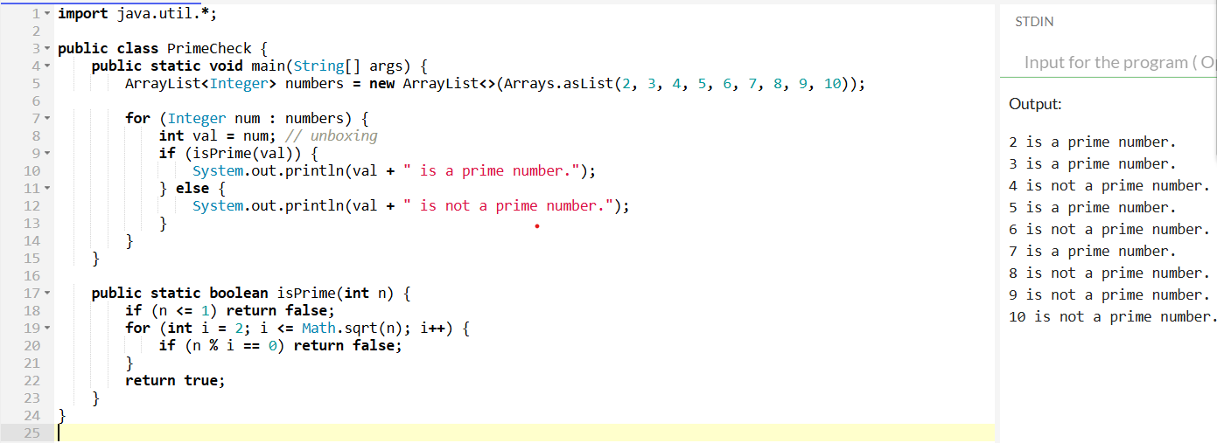
- Create an ArrayList to store Employee objects with attributes like name, id, and salary. Add three employees, update one employee's salary, remove another by their id, and print the remaining employees.
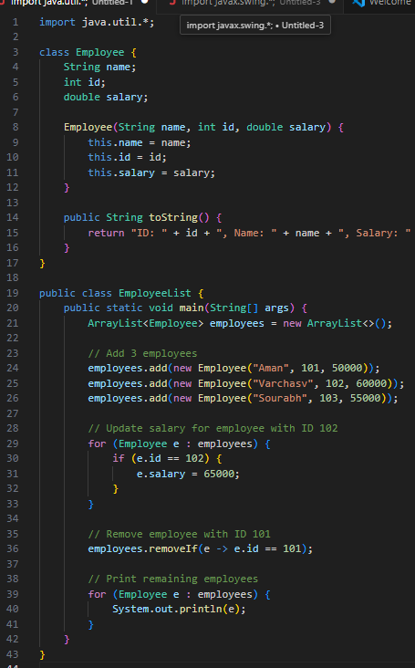
- Use a HashMap to manage a product inventory where keys are productId (Integer) and values are quantity (Integer). Add three products, update the quantity of one product, remove another, and display the final inventory.
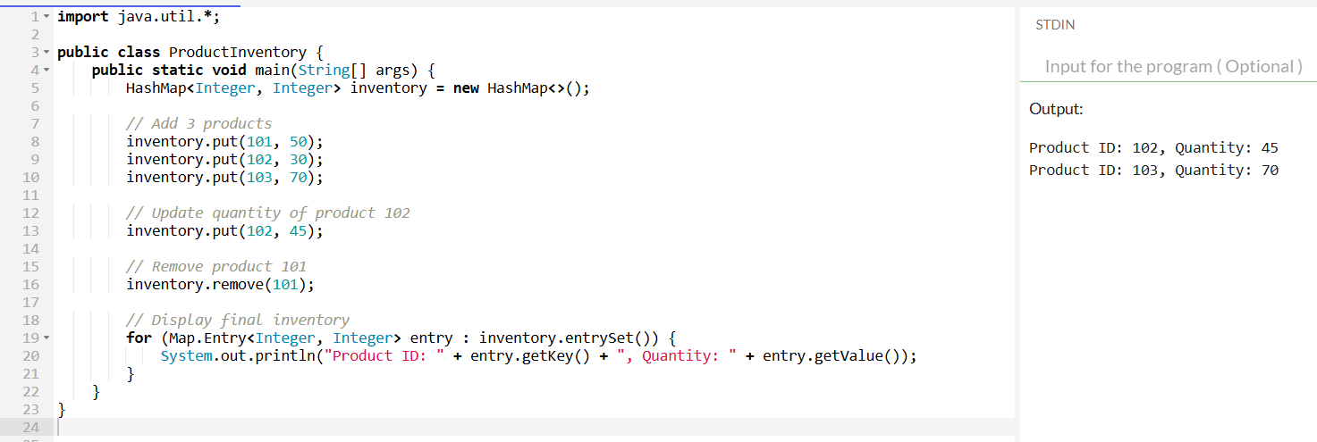
- Given an array of names with duplicates (e.g., ["Aman", "Varchasv", "Sourabh", "Varchasv", ”Aman”]), store them in a HashSet to eliminate duplicates. Check if a specific name exists in the set and print the unique names.
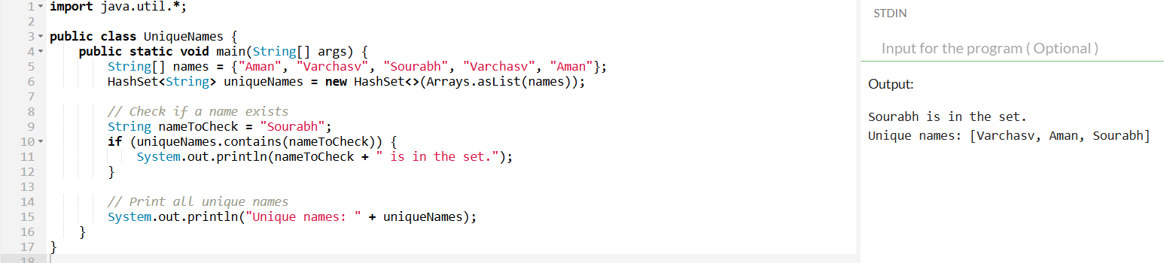
- Given an ArrayList of integers (possibly with duplicates), find the sum of its unique values. [Hint: Convert it to HashSet]
Example:
Input: [3, 5, 3, 8, 2, 5]
Unique values: [3, 5, 8, 2]
Sum: 18
